Week 9:

--Two – Dimensional and Multi – Dimensional Array

ROLL NO.:241501202

Name: shri vishal sv

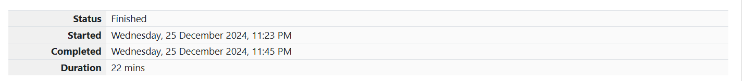

Q1) 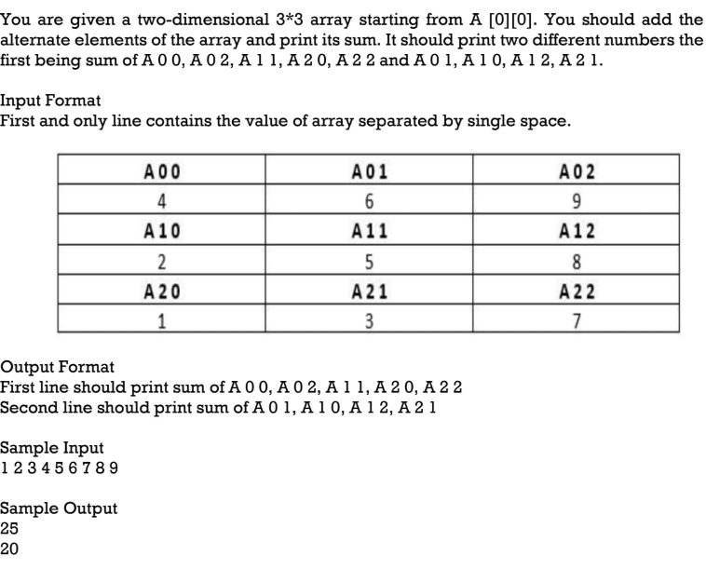

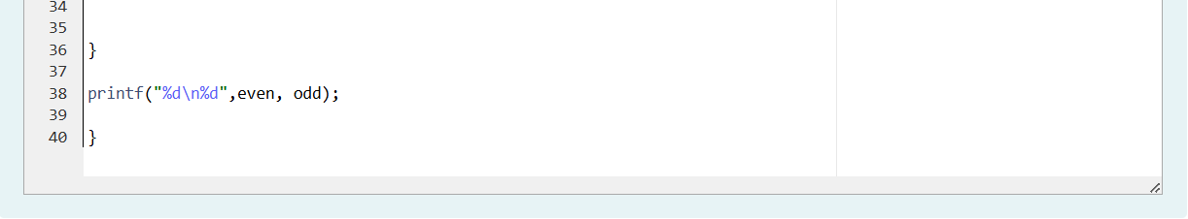

OUTPUT:

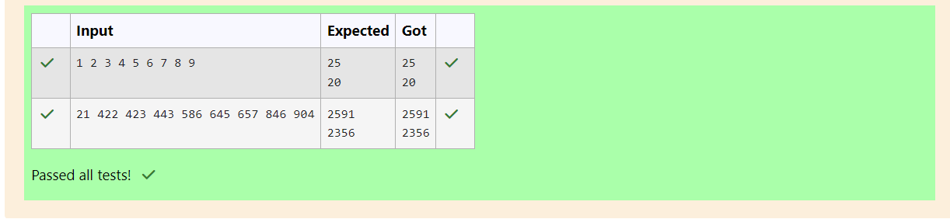

**Q2**) Microsoft has come to hire interns from your college. N students got shortlisted out of

which few were males and a few females. All the students have been assigned talent

levels. Smaller the talent level, lesser is your chance to be selected. Microsoft wants to

create the result list where it wants the candidates sorted according to their talent levels,

but there is a catch. This time Microsoft wants to hire female candidates first and then male

candidates. The task is to create a list where first all-female candidates are sorted in a

descending order and then male candidates are sorted in a descending order.

**Input Format**

The first line contains an integer N denoting the number of students. Next, N lines contain

two space-separated integers, ai and bi. The first integer, ai will be either 1(for a male

candidate) or 0(for female candidate). The second integer, bi will be the candidate's talent

level.

**Constraints:**

1 <= N <= 105, 0 <= ai <= 1, 1 <= bi <= 109

**Output Format**

Output space-separated integers, which first contains the talent levels of all female

candidates sorted in descending order and then the talent levels of male candidates in

descending order.

**Sample Input**

5

0 3

1 6

0 2

0 7

1 15

**Sample Output**

7 3 2 15 6

**

OUTPUT:

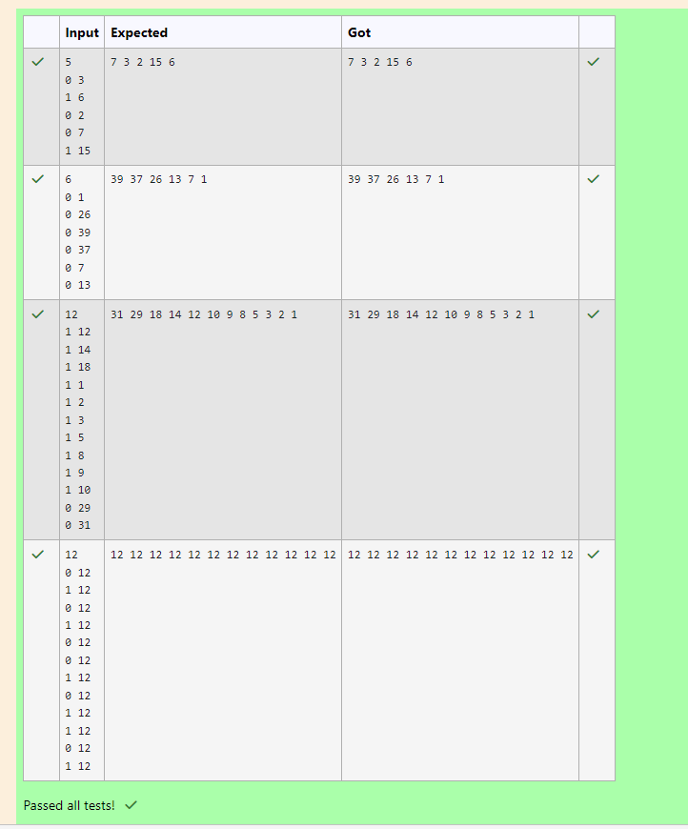

**Q3)** Shyam Lal, a wealthy landlord from the state of Rajasthan, being an old fellow and tired of

doing hard work, decided to sell all his farmland and to live rest of his life with that money.

No other farmer is rich enough to buy all his land so he decided to partition the land into

rectangular plots of different sizes with different cost per unit area. So, he sold these plots

to the farmers but made a mistake. Being illiterate, he made partitions that could be

overlapping. When the farmers came to know about it, they ran to him for compensation

of extra money they paid to him. So, he decided to return all the money to the farmers of

that land which was overlapping with other farmer's land to settle down the conflict. All

the portion of conflicted land will be taken back by the landlord.

To decide the total compensation, he has to calculate the total amount of money to return

back to farmers with the same cost they had purchased from him. Suppose, Shyam Lal has

a total land area of 1000 x 1000 equal square blocks where each block is equivalent to a

unit square area which can be represented on the co-ordinate axis. Now find the total

amount of money, he has to return to the farmers. Help Shyam Lal to accomplish this task.

**Input Format**:

The first line of the input contains an integer N, denoting the total and pieces

he had distributed. Next N line contains the 5 space separated integers (X1, Y1), (X2, Y2)

to represent a rectangular piece of land, and cost per unit area C.

(X1, Y1) and (X2, Y2) are the locations of first and last square block on the diagonal of the

rectangular region.

**Output Format:**

Print the total amount he has to return to farmers to solve the conflict.

**Constraints:**

1 ≤ N ≤ 100

1 ≤ X1 ≤ X2 ≤ 1000

1 ≤ Y1 ≤ Y2 ≤ 1000

1 ≤ C ≤ 1000

**Sample Input**

3

1 4 4 6 1

4 3 6 6 2

2 2 5 4 3

**Sample Output**

35

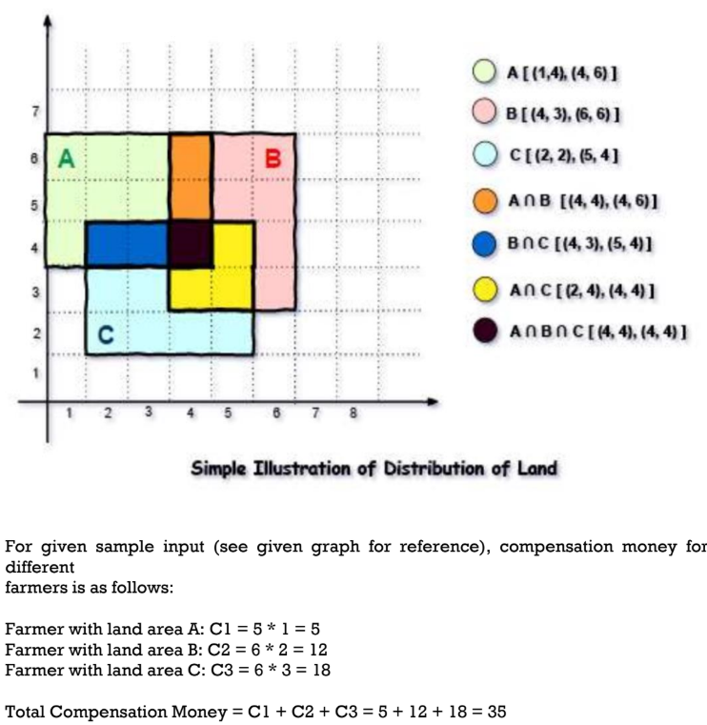

**Code:**

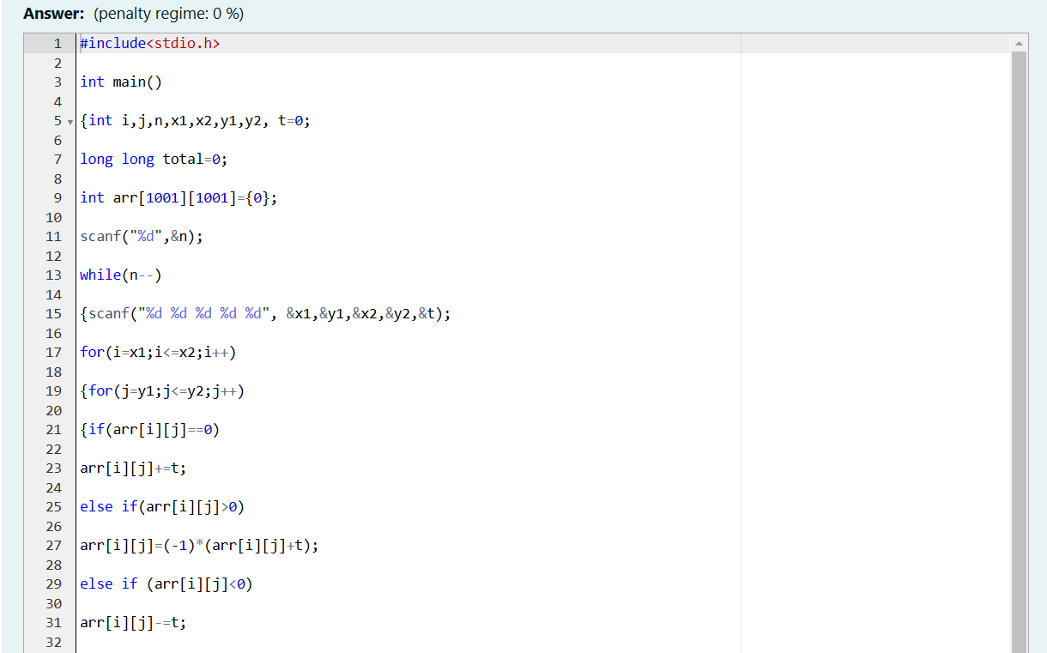

OUTPUT:

